**CAS 756 Assignment 1**

**1 – Conference DSL**

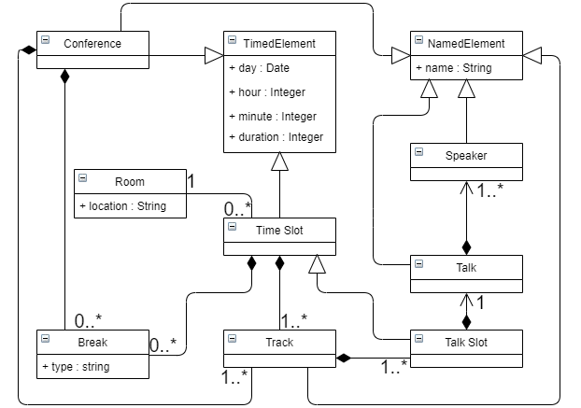

**2 – Software Distribution DSL**

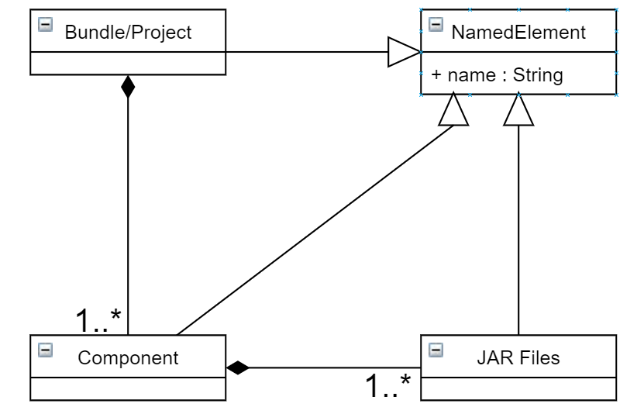

Constraints for Software Distribution DSL**:**

* Components can require other components (dependency)
* Sharable JAR files

Model:

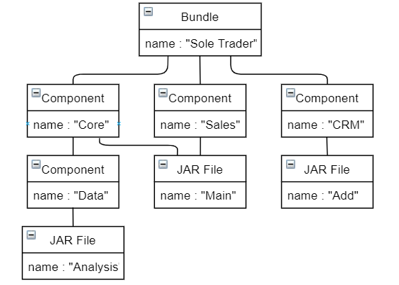

**3 – Research Project DSL**

* Metamodel:

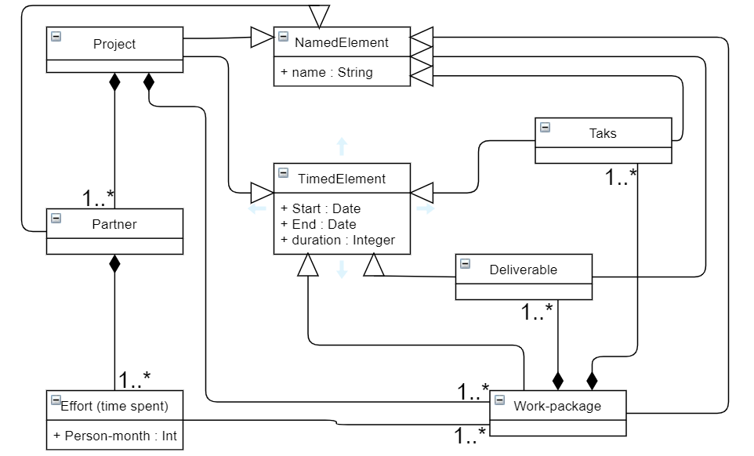

* Model:

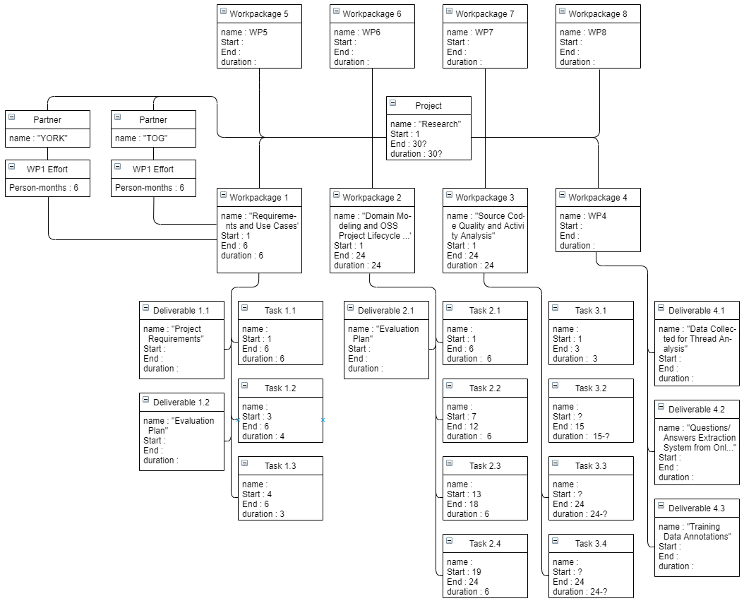

Baran Kaya, 400284996, [kayab@mcmaster.ca](mailto:kayab@mcmaster.ca)